Installing wireshark and analysing network packet stream

Wireshark is a free and open-source network protocol analyser widely used around

the globe. With Wireshark, you can capture incoming and outgoing packets of a

network in real-time and use it for network troubleshooting, packet analysis,

software and communication protocol development, and many more.

Procedure:

Step 1: Update the system

sudo apt-get update

Step 2: Install wireshark on the system

sudo apt-get install wireshark

Step 3: Check the version

wireshark –version

OUTPUT

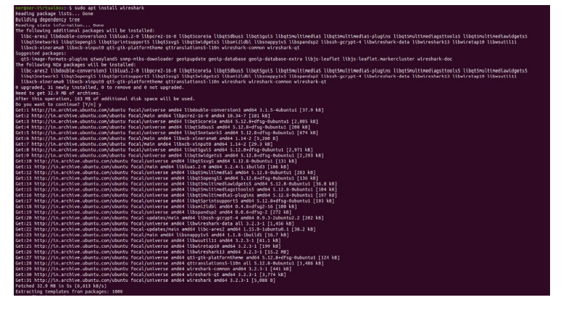

To capture network packet streams type, wireshark

then copy the ip address

